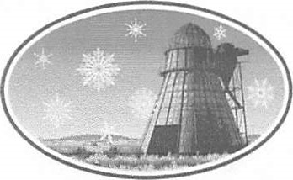
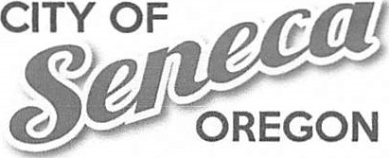
106 A Ave., PO Box 208
Seneca, OR 97873 (541) 542-2161 www.SenecaOregon.com

Notice of City Council Meeting Including Public Hearing
City of Seneca – City Council Meeting Agenda
January 13, 2025 – 6:00 PM
City Hall, 106 A Ave
New Business
• Public Hearing (held during the City Council Meeting) – Grant County Library District
The purpose of the public hearing is to receive public comment regarding potential City participation in the formation of a Grant County Library District and related matters. You are encouraged to submit a written statement if you can not make the meeting.
Open Floor
Advertising Seneca
Action Items
Appoint Budget Officer
Library District Resolution – Discussion and possible action
Bills before Council
This meeting is open to the public. This agenda includes a list of the principal subjects anticipated to be considered at the meeting. However, the agenda does not limit the ability of the Council to consider additional subjects. Meetings may be canceled without notice.

