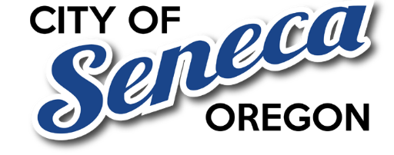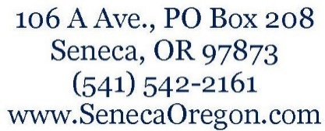

STAFF REPORT
City of Seneca City Council
Agenda Item: Resolution Regarding Inclusion of Seneca Residents in Proposed Grant County Special Library District
Meeting Date: January 10th 2026
Prepared by: City Manager/Recorder Deborah Oatman.

I. PURPOSE OF THIS REPORT
The purpose of this staff report is to provide factual background and local context to assist City Council in considering whether to adopt a resolution that would allow Seneca residents to be included in a countywide ballot measure to form a Special Library District.
Adoption of the resolution would not impose a tax and would not commit City funds. It would only determine whether Seneca residents may participate in the countywide vote.

II. BACKGROUND
Grant County has indicated that it will no longer provide operational funding for the Grant County Library after June 30, 2026. In response, a citizen group known as the Save Our Library Committee has proposed formation of a Special Library District as a potential long-term funding mechanism.
Under Oregon law, formation of a special district requires voter approval. Incorporated cities must adopt a resolution in order for their residents to be included in the election and, if approved, included within the district boundaries.

III. LOCAL CONDITIONS IN SENECA
When considering whether to allow residents to vote on inclusion in a Special Library District, staff notes the following local conditions specific to the City of Seneca:

1. Distance to Library Services
- Seneca is located approximately 35 minutes by vehicle from the nearest library facility.
- This distance may limit practical access for some residents, particularly those without reliable transportation.

2. Broadband and Digital Access
- Many Seneca households have broadband internet access, allowing residents to obtain:
  - Digital information
  - Online educational resources
  - E-books and remote services
- For some residents, digital access may reduce reliance on physical library facilities.

3. Community Income Considerations
- Seneca is a lower-income community relative to other areas in Grant County.
- Additional property taxes may have a disproportionate impact on residents with fixed or limited incomes.
- Community members have expressed concern about cumulative tax burdens and affordability.

IV. FISCAL IMPACT TO THE CITY
- There is no fiscal impact to the City of Seneca from adopting or not adopting the resolution.
- The City would not collect, manage, or distribute library district funds.
- Any future tax would be:
  - Approved or rejected by voters
  - Levied and administered by the library district, not the City

V. IMPACT TO RESIDENTS
If the resolution is adopted:
- Seneca residents may vote on the proposed district.
- If approved countywide, residents would pay the district tax and be entitled to district services.
If the resolution is not adopted:
- Seneca residents would not vote on the measure.
- If a district is formed, Seneca residents would not be included and may be subject to out-of-district user fees for library service

VI. COUNCIL CONSIDERATION
Council action on this item determines ballot participation only.
It does not represent:
- An endorsement of the library district
- A commitment to taxation
- A policy position on library services
Council may consider whether allowing residents to vote aligns with
- Local access realities
- Economic conditions
- Community priorities

