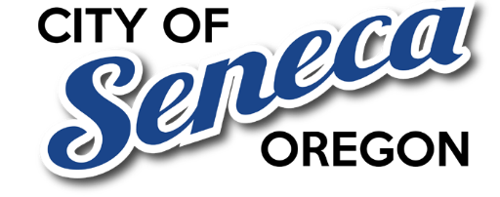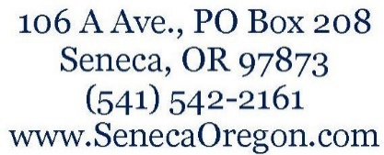

ADDITION TO STAFF REPORT

Operations & Maintenance–Only (O&M) Model – Overview
An Operations & Maintenance–only (O&M) model would focus library funding exclusively on keeping existing services operational, without funding capital expansion, facility replacement, or construction of new buildings.
Under this model:
- Funding is limited to:
  - Staff
  - Utilities
  - Routine maintenance
  - Materials and programming
- Capital projects (new buildings, major expansions, or replacements) are explicitly excluded.
- The existing library facility is maintained rather than replaced.
This model prioritizes service continuity and affordability over growth.

Relevance to Seneca
Staff notes that an O&M-only model may be particularly relevant given:
- Seneca’s distance from the physical library
- Broadband availability reducing reliance on in-person services
- Community sensitivity to additional property taxes
- Desire to avoid creating tax capacity for future capital expansion

Comparison to Special Library District Model
Issue | O&M-Only Model | Full Library District
New Tax | Possibly lower or none | Required
Capital Projects | Not allowed | Allowed
Governance | More constrained | Broad authority
Tax Stability | Limited | Permanent
Facility Expansion | No | Possible
Local Control | Higher | Lower

Key Policy Consideration
Formation of a permanent library district creates long-term taxing and capital authority beyond current operational needs. An O&M-only model limits scope to essential services and may better align with smaller, rural communities.

COUNCIL TALKING POINTS (O&M MODEL)
- “We are interested in sustaining basic services, not expanding facilities.”
- “An operations-only model limits tax exposure and future capital obligations.”
- “Seneca residents are more likely to support maintenance than expansion.”
- “This approach aligns with broadband access and rural realities.”
- “Future boards would not have authority to pursue new construction.”

Neutral framing language for the record
You can say:
“Council is seeking clarification on whether an operations-and-maintenance–only approach could meet service needs while limiting long-term tax exposure and capital expansion.”
That keeps you neutral, factual, and defensible.

Reality check (for you, not the record)
Most advocacy groups do not prefer O&M-only models because:
- They limit future flexibility
- They restrict capital growth
- They reduce campaign appeal
But from a governance and affordability perspective, it is a completely valid policy option.

