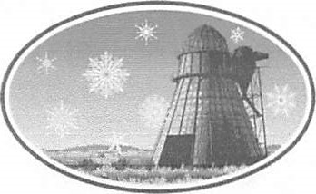

106 A Ave., PO Box 208
Seneca, OR 97873 (541) 542-2161 www.SenecaOregon.com

Public Notice
City Council & Budget Metting
City of Seneca Council Meeting Agenda
March 10th 2026 6pm @
City Hall 106 A Ave

New Business
Approve February Minutes
Zwygart CPA Audit Update
Open Floor
Resolution 2026-2 & 2026-3 (transferring appropriations)
Bills Before Council

Budget Committee Meeting
Elect Budget Committee Chair
Review of Proposed Budget
Budget Discussion

This is a public meeting where deliberations of the Budget Committee will take place. Any person may attend and provide comment on the proposed budget.

This meeting is open to the public. This agenda includes a list of the principal subjects anticipated to be considered at the meeting. However, the agenda does not limit the ability of the Council to consider additional subjects. Meetings may be canceled without notice.

